Cairo University Faculty of Computers and Artificial Intelligence



**Software Design and Architecture**

**Software design specification document**

**2021**

**Project Team**

|  |  |  |  |
| --- | --- | --- | --- |
| **ID** | **Name** | **Email** | **Mobile** |
| **20190186** | **Khaled Ashraf Hanafy Mahmoud** | **5aleda4rf@gmail.com** | **01064502336** |
| **20190034** | **Ahmed Sayed Hassan Youssef** | **Midosayed1762001@gmail.com** | **01125372118** |
| **20190224** | **Zeyad Maher Mahmoud Mohammed** | **Zeyadmaher638@gmail.com** | **01148553837** |
| **20190009** | **Ebrahim Mohamed Ebrahim Hegy** | **e.muuhammed@gmail.com** | **01123768660** |

**Eng: Hassan Mourad**

Contents

Class diagram design 2

Sequence diagram design 3

Github repository link 5

# Class diagram design

# Sequence diagram design

1. **Customer Register**

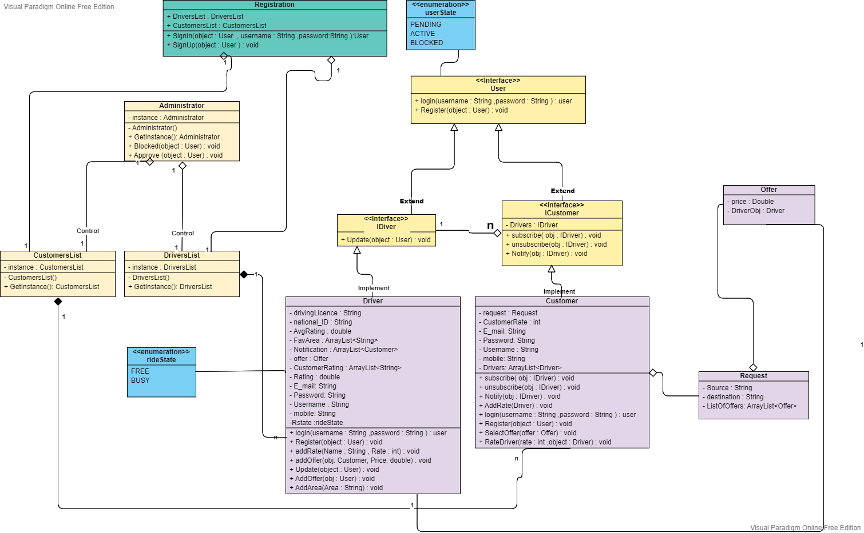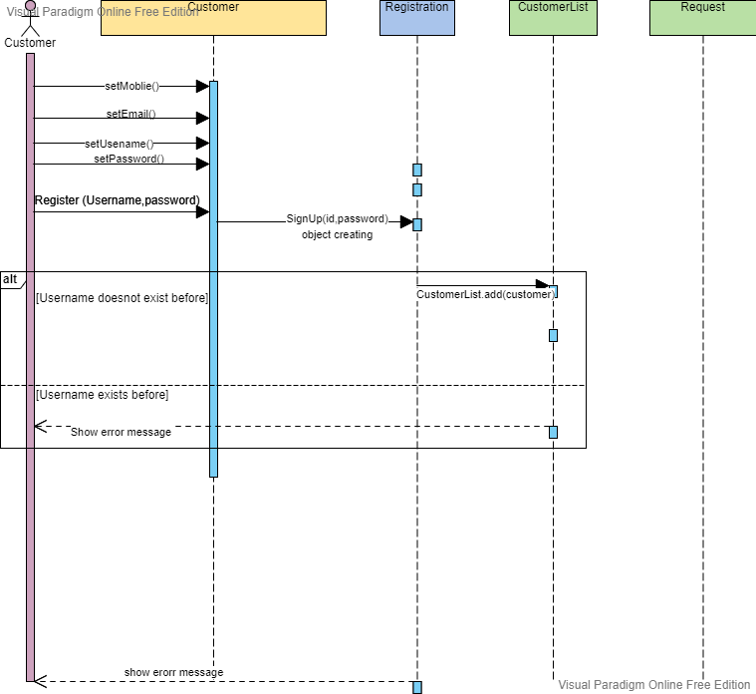

1. **Add Offer**

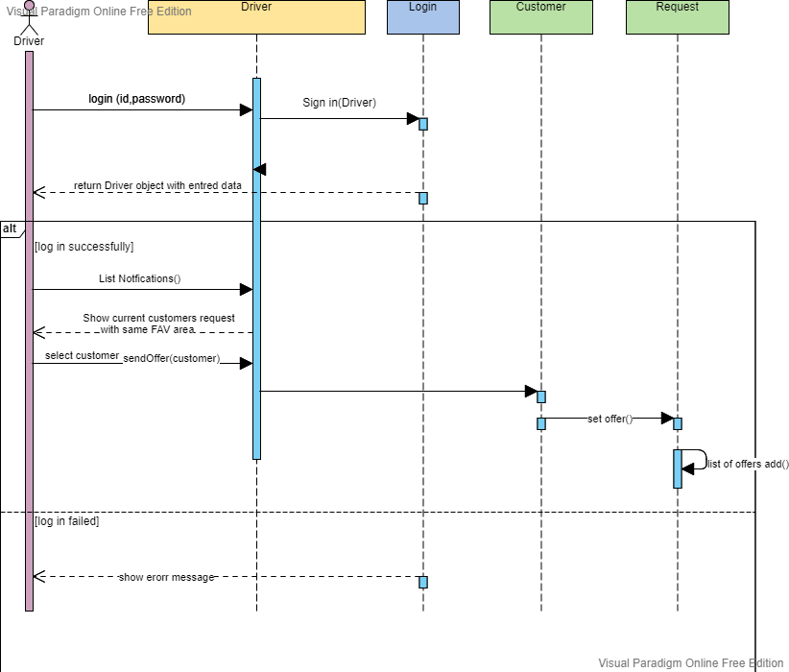

1. **Add Rate**

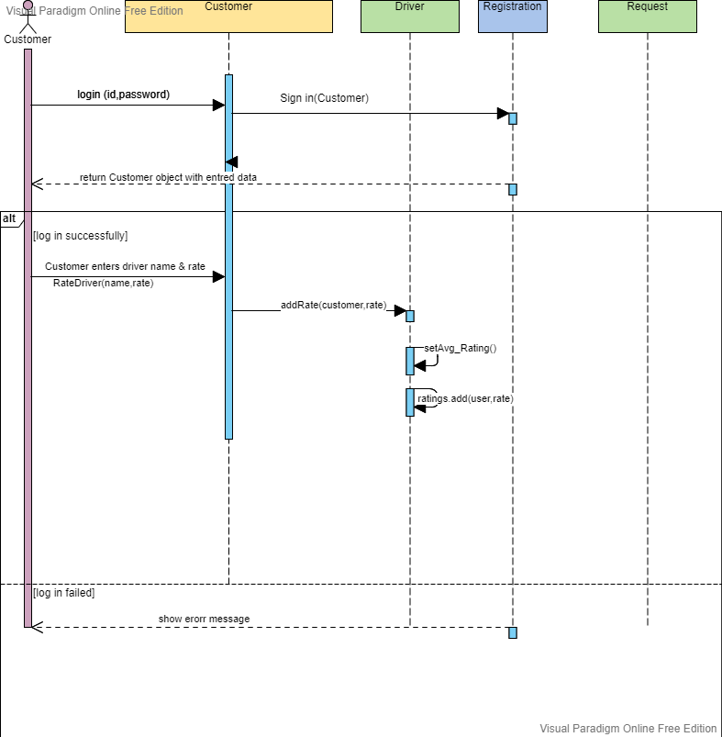

1. **Send Request to Drivers**

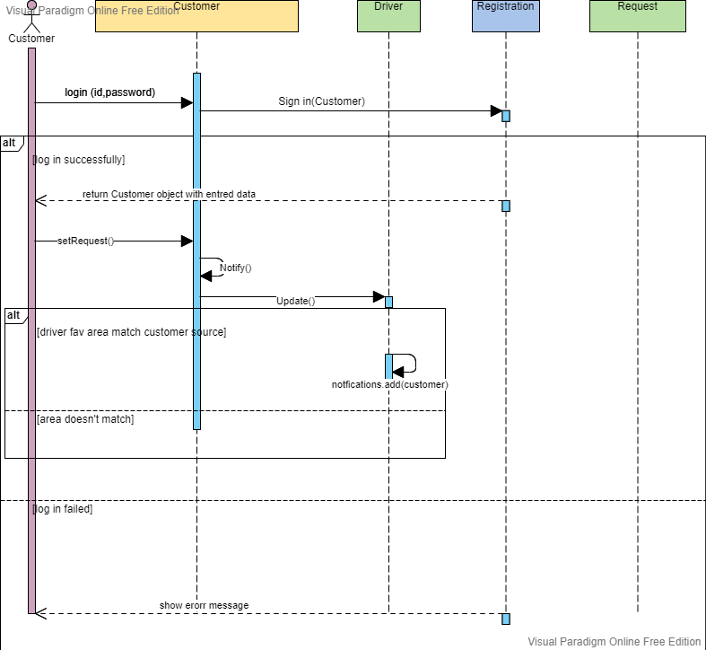

1. **Login Driver**

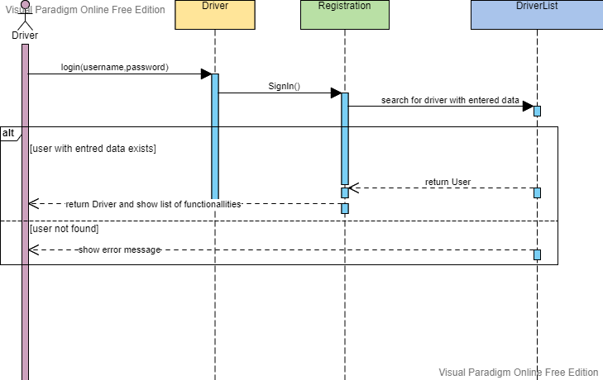

1. **Login Customer**

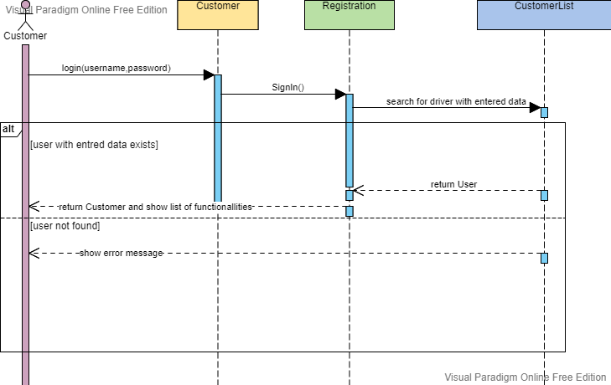

**7.calculation Rate**

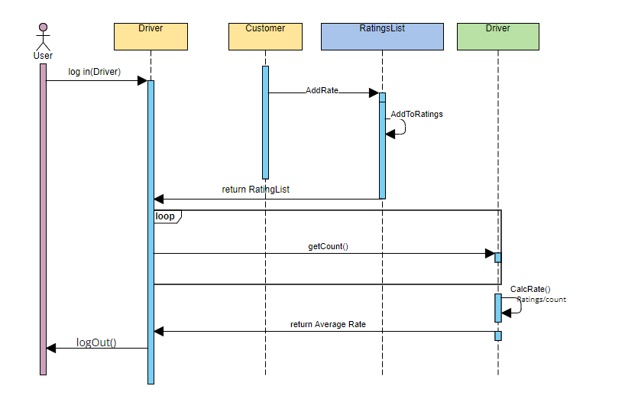

1. **Block User**

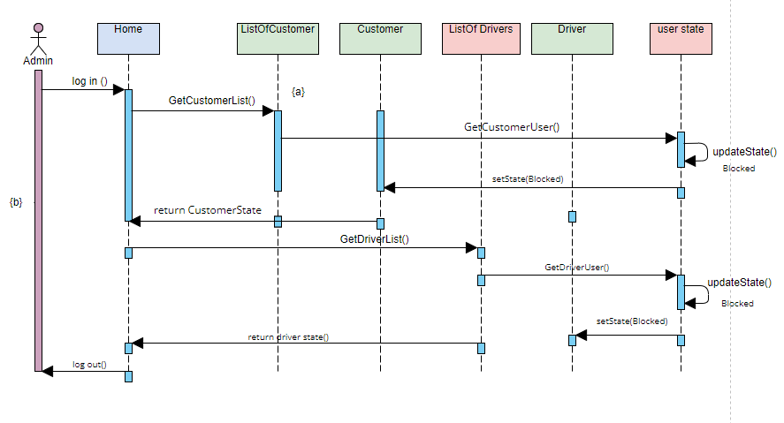

# Github repository link

* [***https://github.com/Mido1762001/SW2-20190034_20190186_20190009_20190224***](https://github.com/Mido1762001/SW2-20190034_20190186_20190009_20190224)